CENWP-OD-B 09 July 2024

MEMORANDUM FOR THE RECORD

SUBJECT: 24BON020 MFR WA Shore AWS RB2 Pacific Lamprey Mortality

On the morning of 09 July 2024, Project Biologists discovered one adult Pacific Lamprey mortality in the Washington Shore LPS Auxiliary Water Supply (AWS) Rest Box 2. The fish was measured, scanned for PIT tags, inspected, and returned to the river.

- Species – Pacific Lamprey (Entospehnus tridentatus)
- Origin – Unknown
- Length – 68.58cm
- Marks and tags – None
- Marks and Injuries found on carcass – None
- Cause and Time of Death – Unknown
- Future and Preventative Measures – N/A

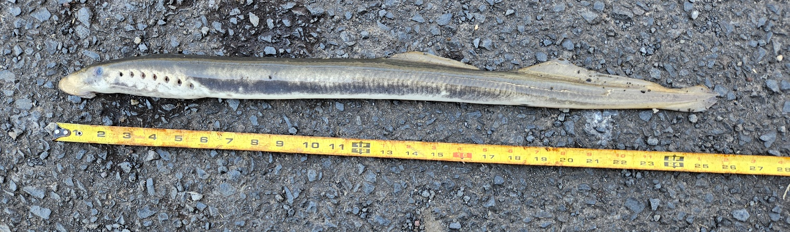

Sincerely,
Project Fisheries

